Project BrainTask Github location:
https://github.com/Shanmugapriya2390/Brain-Tasks-App

Load Balancer ARN:
aef08f783e62048469ec792f95d86085-1599641556.ap-south-1.elb.amazonaws.com

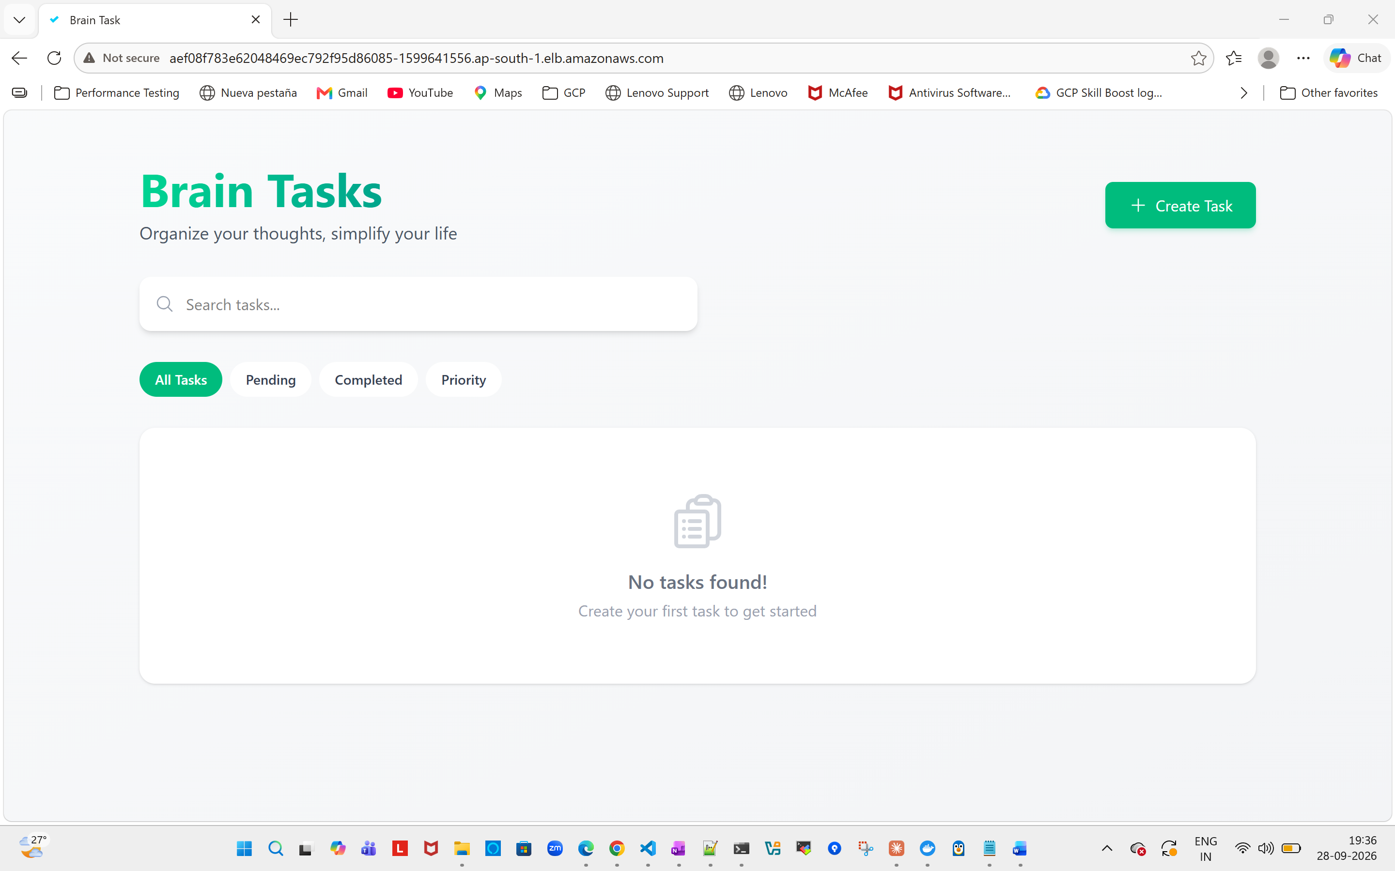

Github Repo:
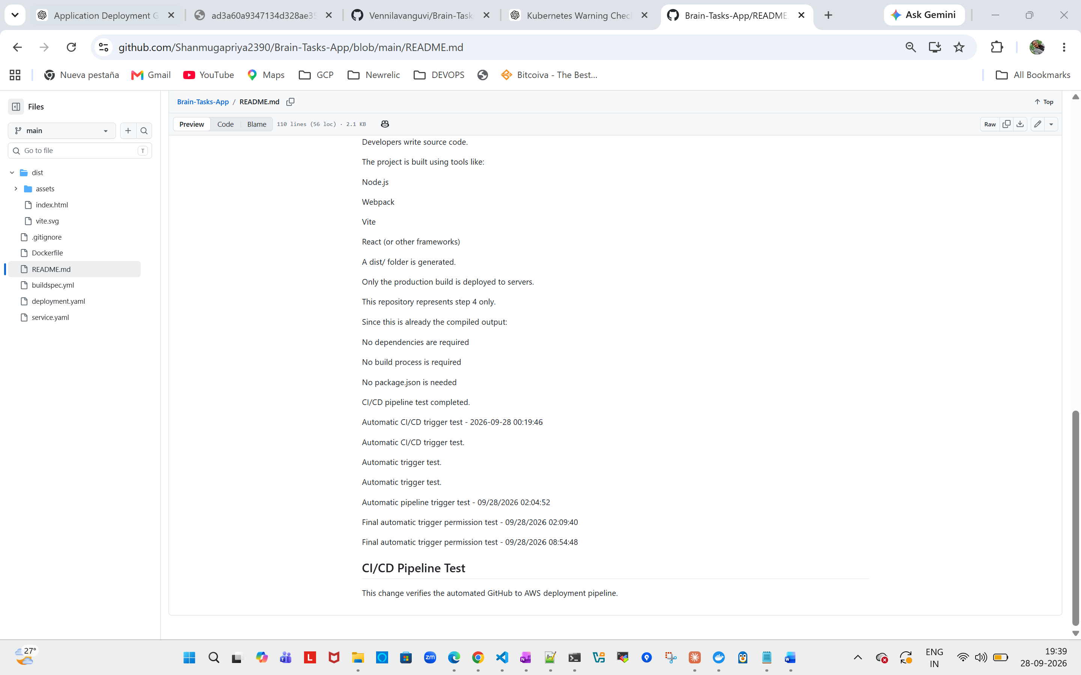

Docker Images:

PS C:\Projects\Brain-Tasks-App> docker images brain-tasks-app
i Info → U In Use
IMAGE ID DISK USAGE CONTENT SIZE EXTRA
brain-tasks-app:1.0 a2e3d6d885d2 94MB 26.4MB U
PS C:\Projects\Brain-Tasks-App>

ECR Image:
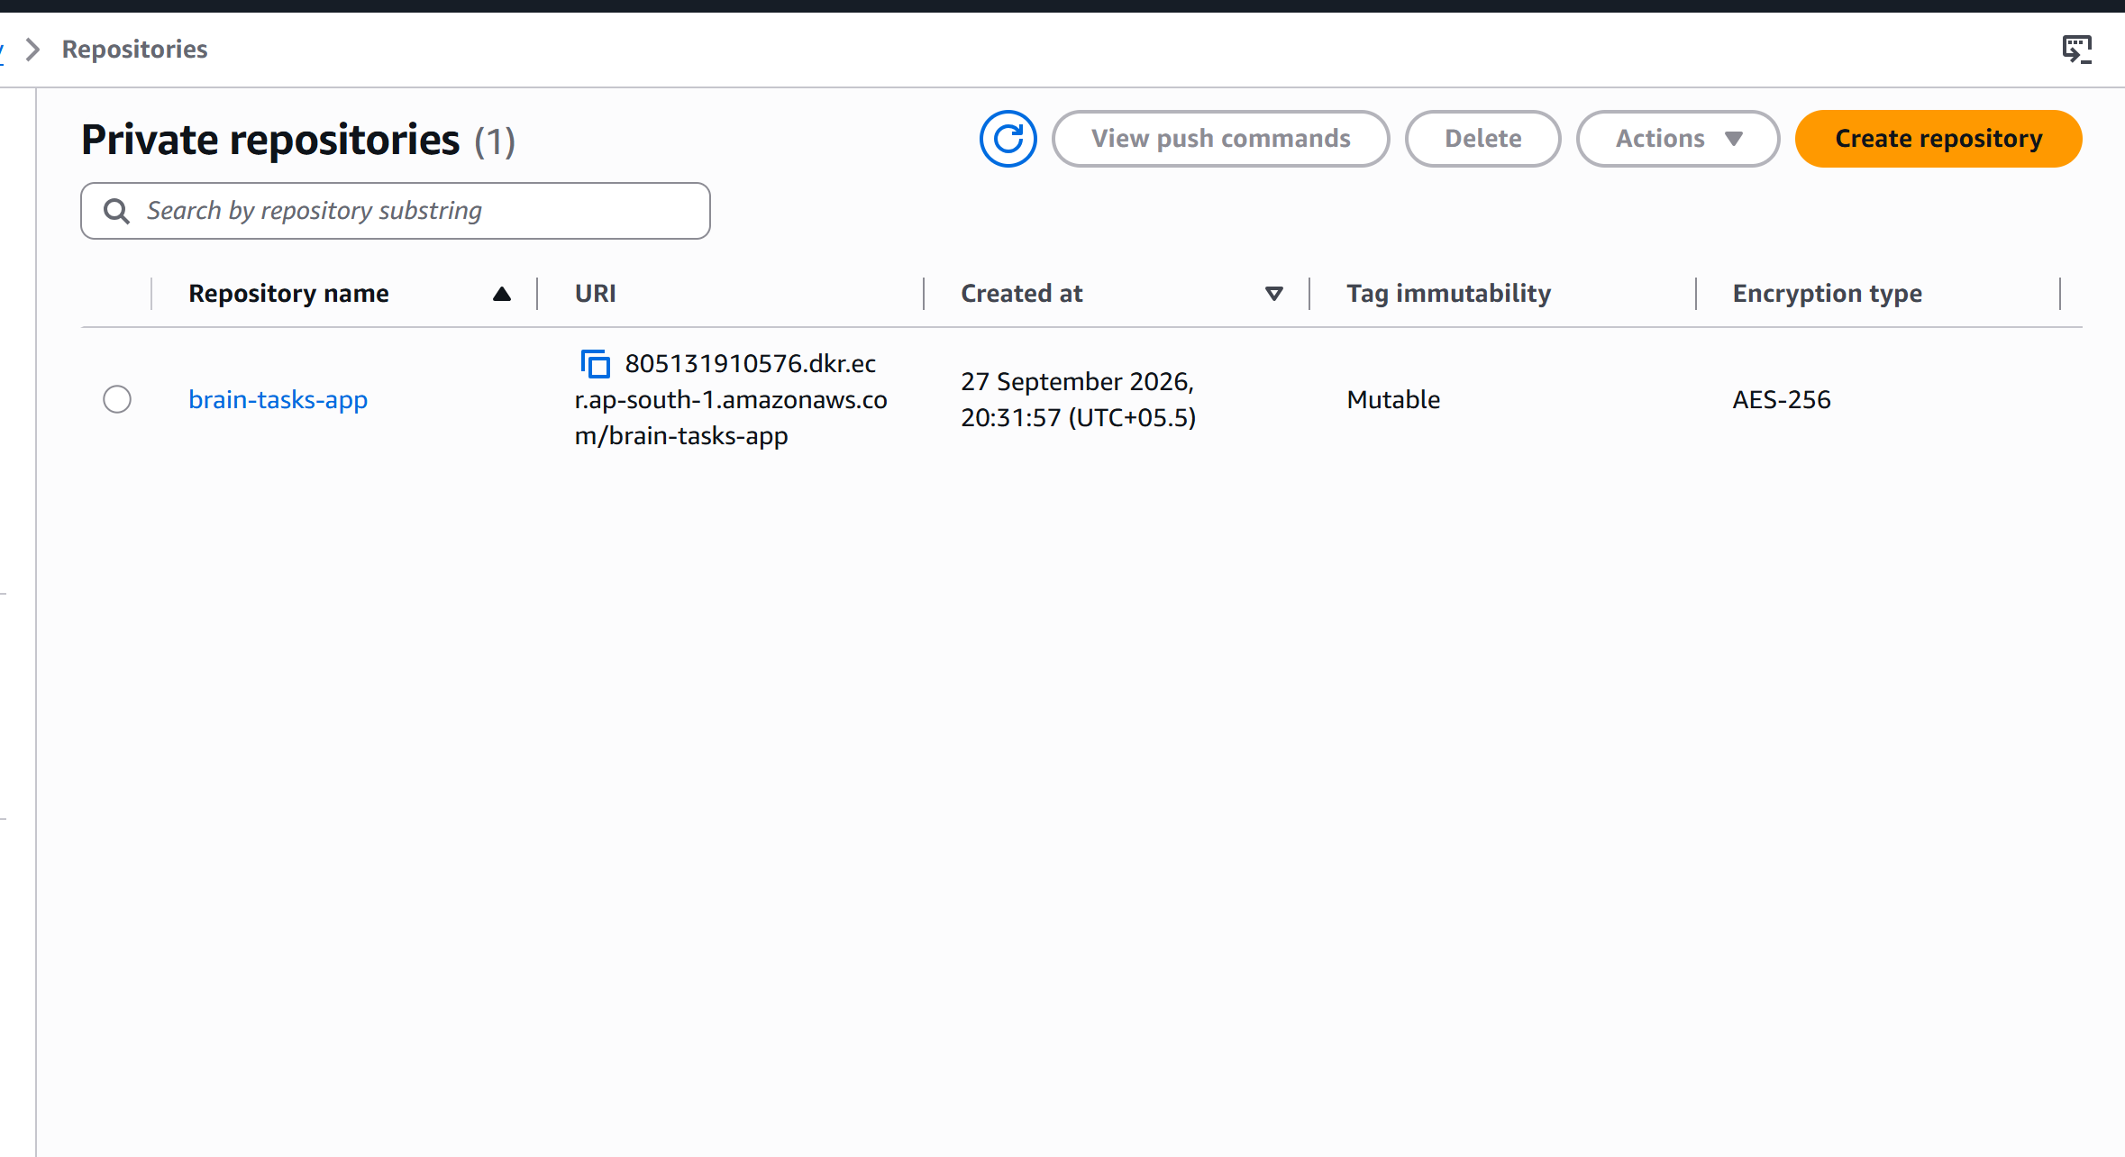
EKS Cluster:
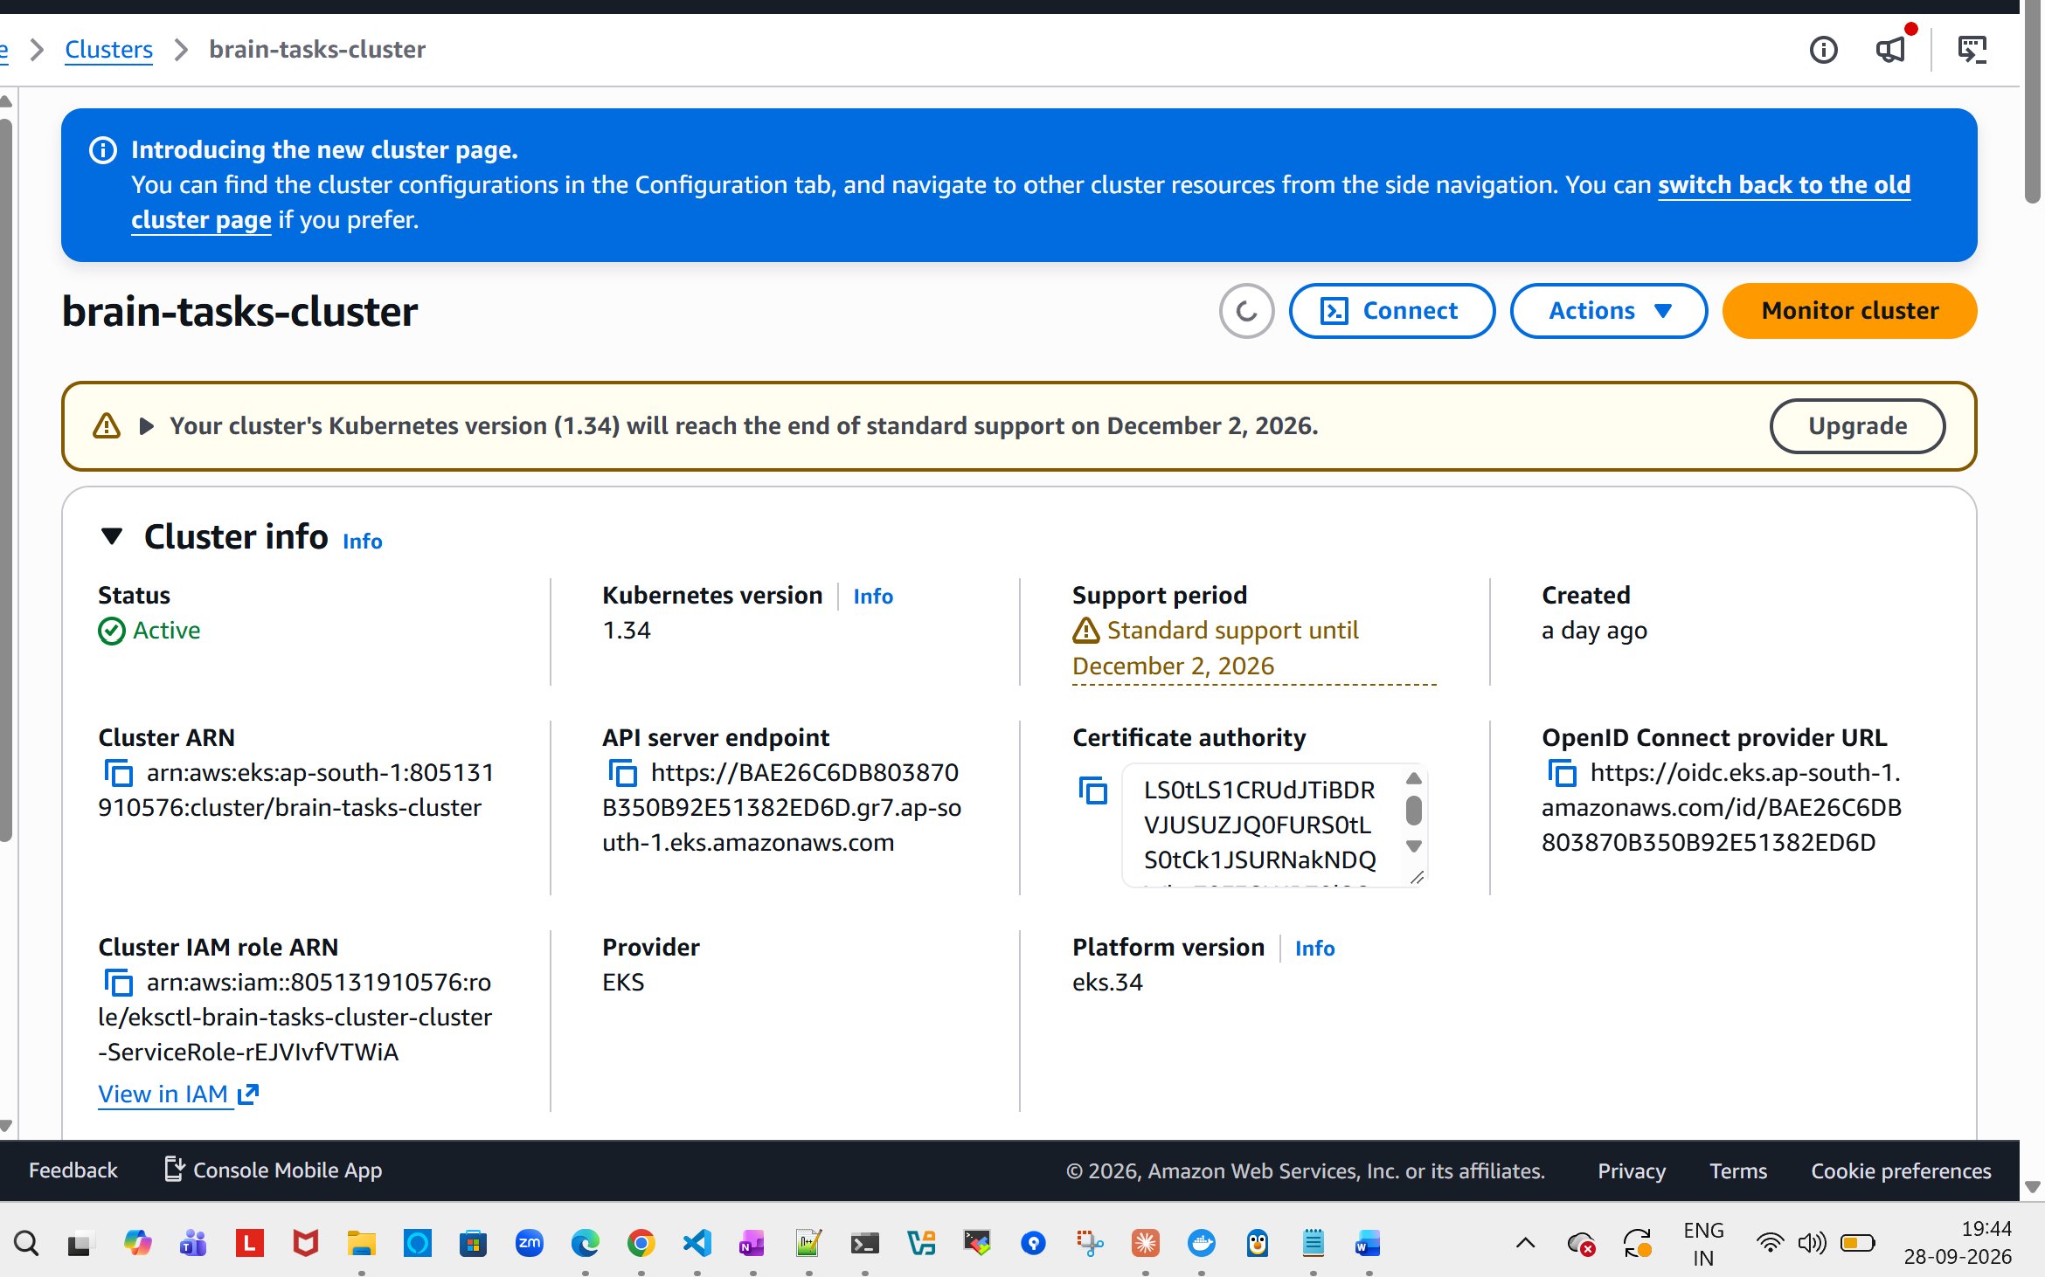

Current Live Deployment:
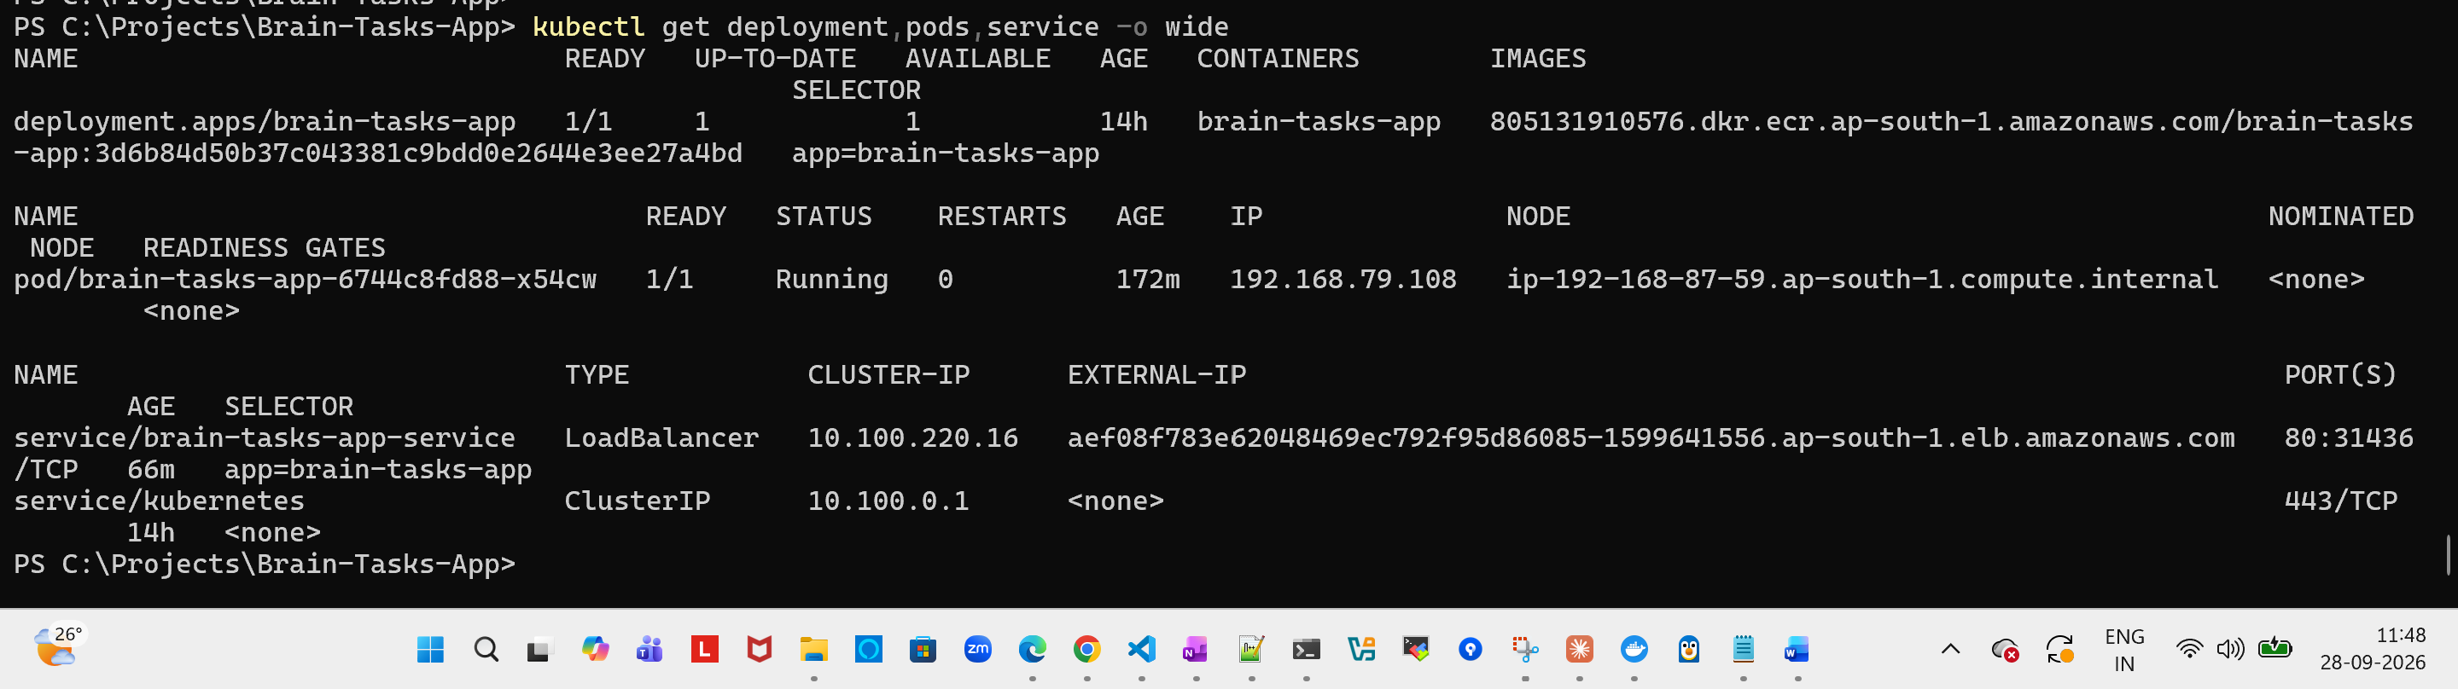

Code Pipeline
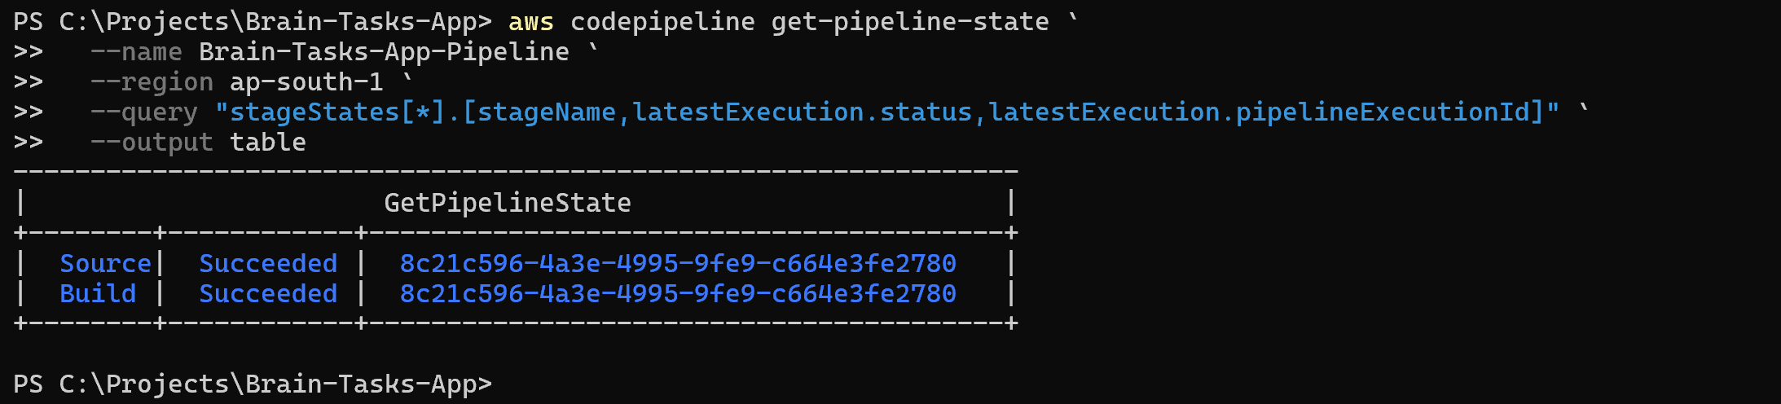

Git push has automatically triggered build pipeplie,

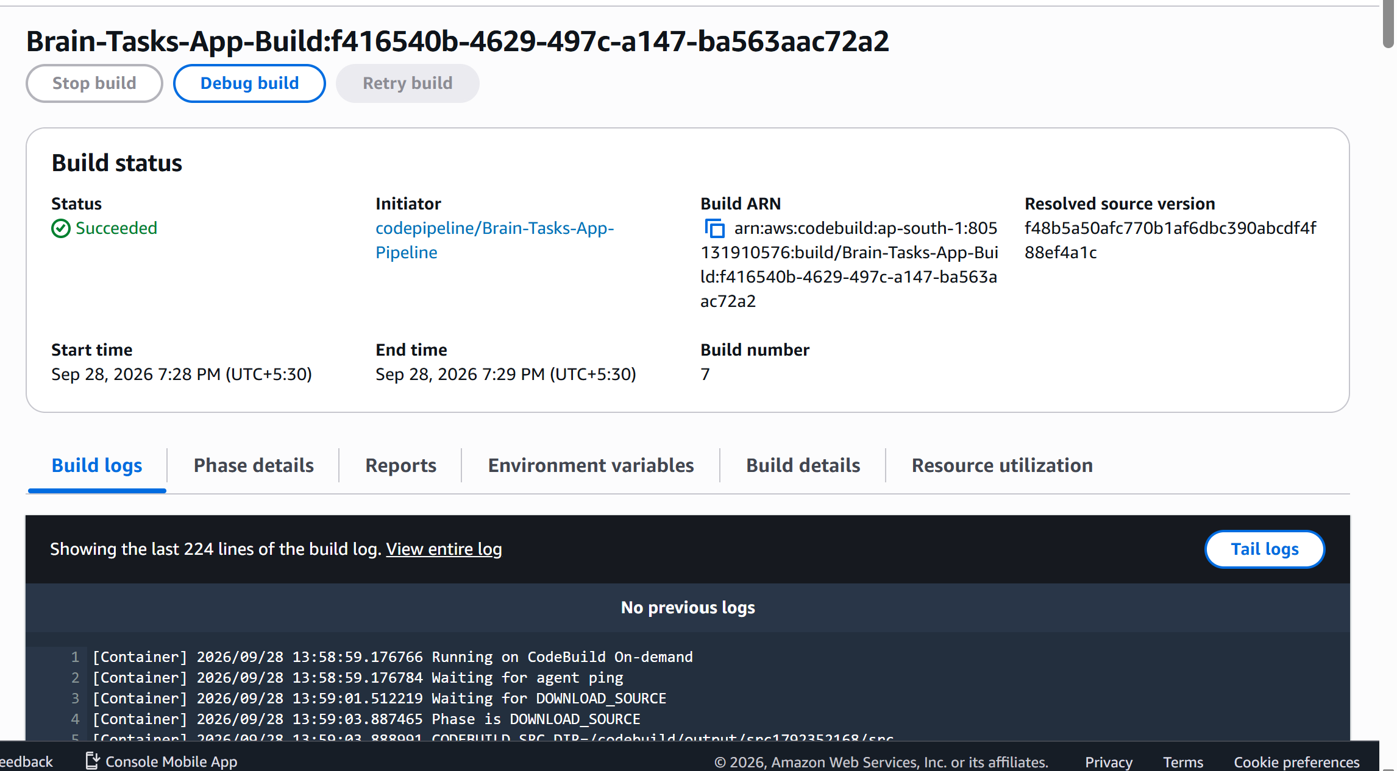
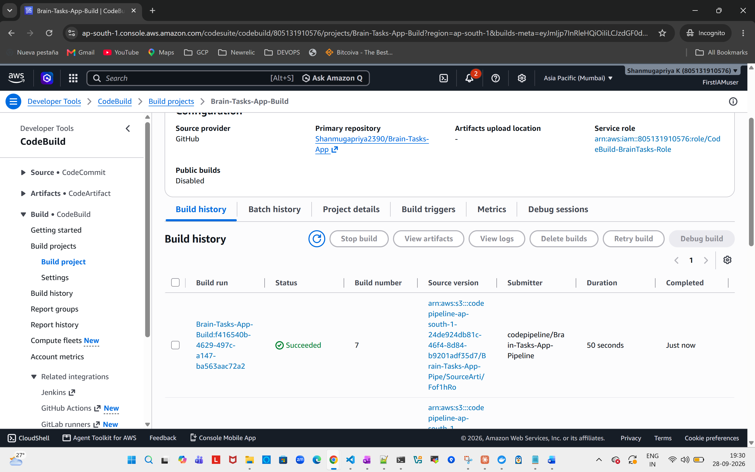

PS C:\Projects\Brain-Tasks-App> kubectl get pods -l app=brain-tasks-app -o wide
NAME READY STATUS RESTARTS AGE IP NODE NOMINATED NODE READINESS GATES
brain-tasks-app-5bb4b98b7d-z8sj7 1/1 Running 0 7m20s 192.168.47.203 ip-192-168-56-14.ap-south-1.compute.internal <none> <none>
PS C:\Projects\Brain-Tasks-App>

CodeBuild:
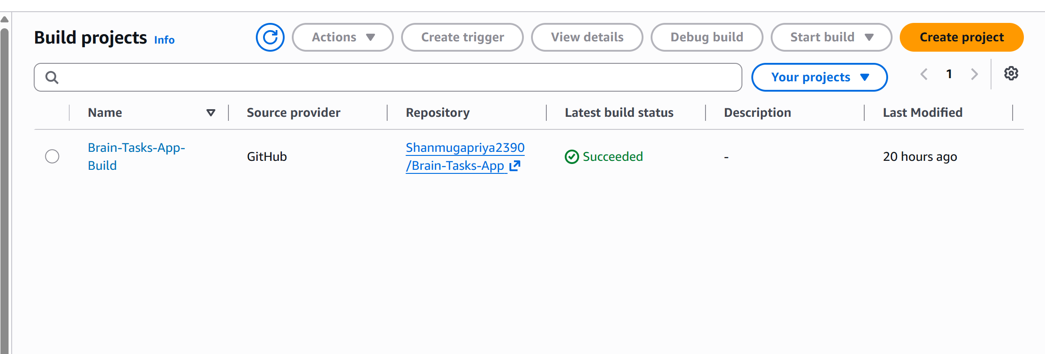
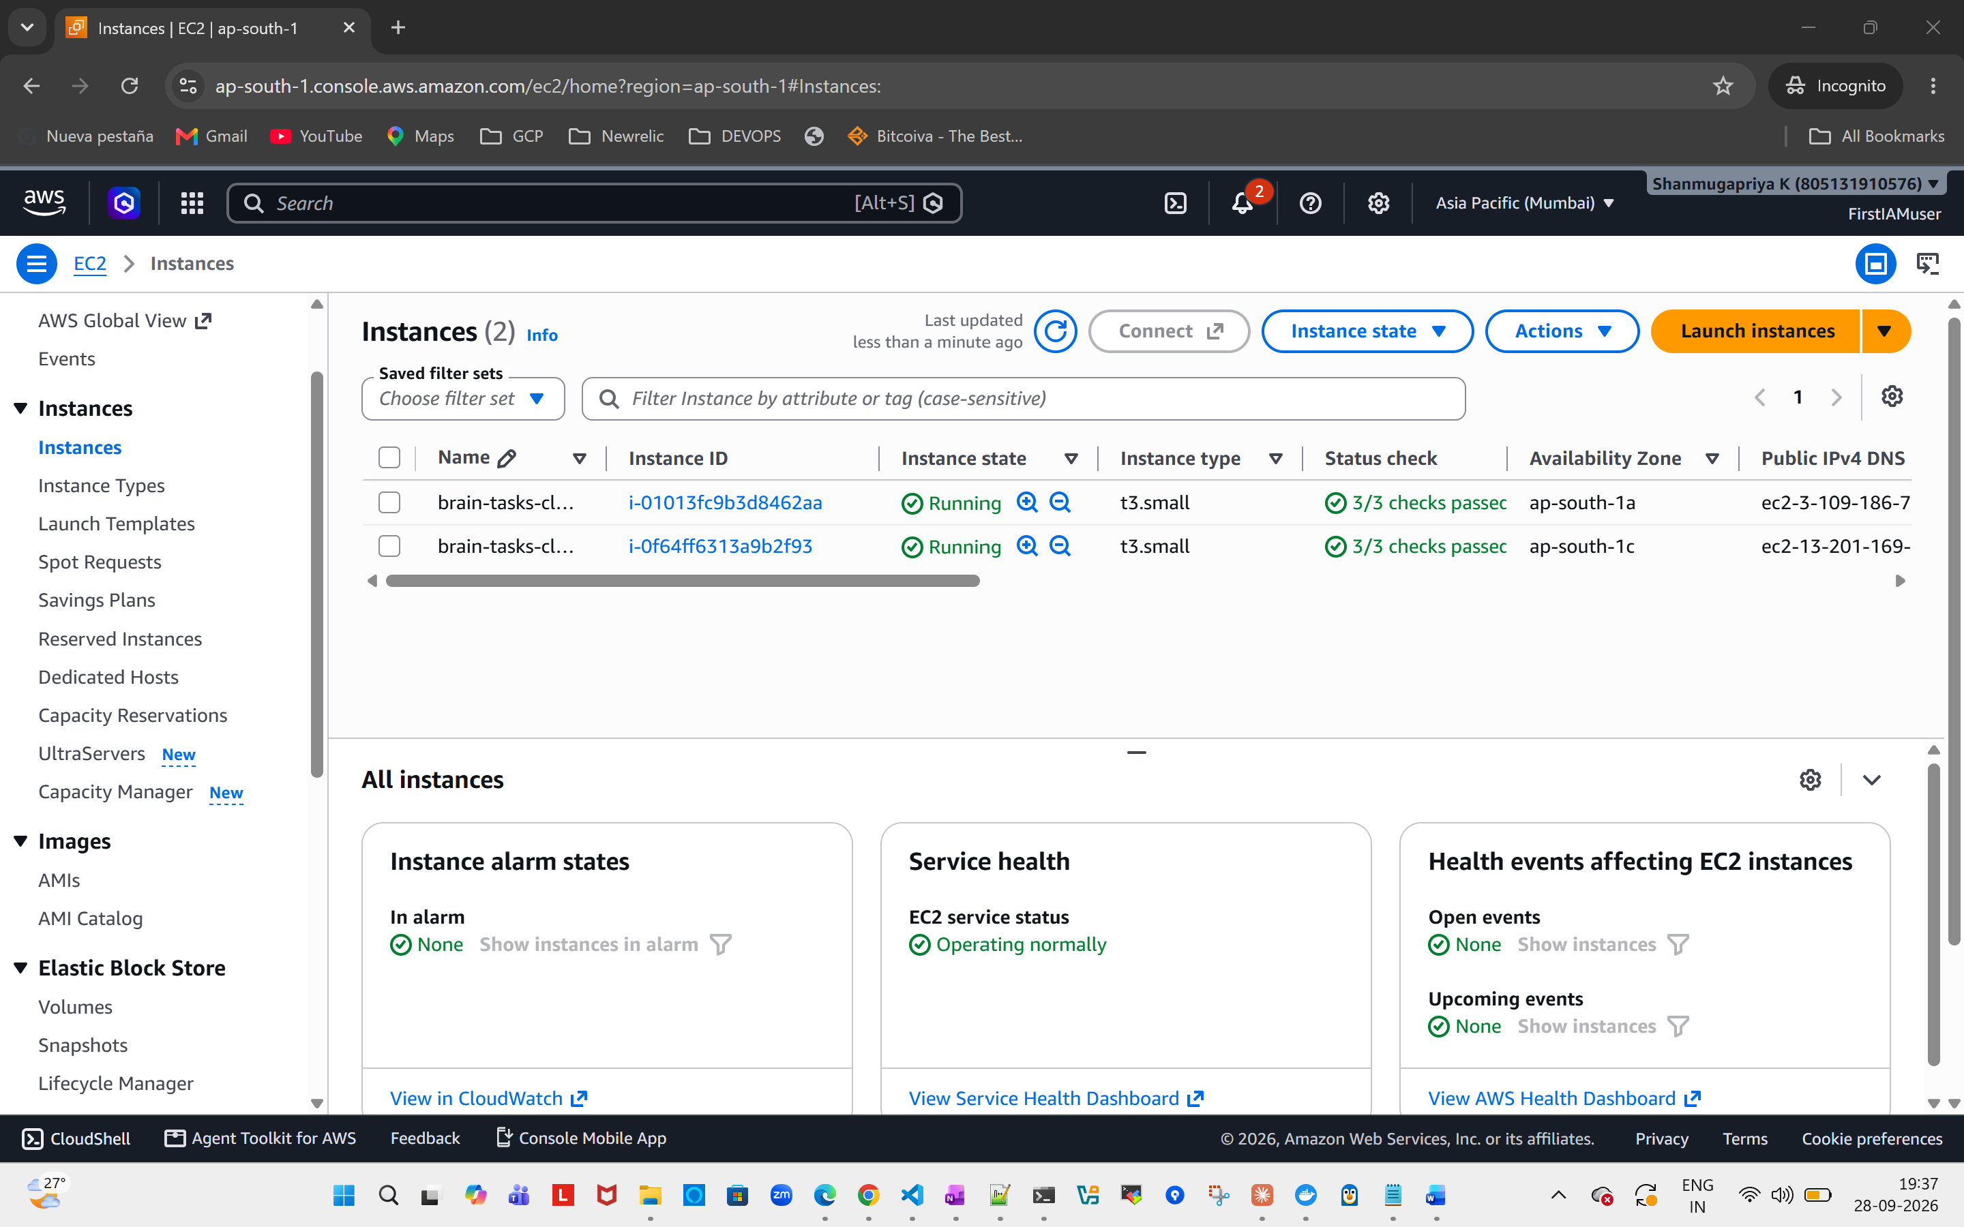

Cloudwatch:
